Reverend Veronica Don 603-878-1684 www.masoncongregatioalchurch.org

Contemplation—a long, loving look. So says Naomi Shahab Nye
Listen, are you breathing just a little, and calling it a life? Mary Oliver
Our live Zoom is easy! You can simply click on the blue link we send out, and a window will open that you say yes, “launch Zoom,” and you are in. If it is your first time on Zoom, it will ask you to download Zoom onto your device then it will give you the launch window.
When you enter zoom, the host will let you in from the ‘waiting room’ and you will be muted when you enter. Simply hover your cursor arrow over the bottom (or sometimes it’s on the top) of your screen, over the little picture of the microphone. If it has a red line, you are muted. Click on it, and you are unmuted! You can stay unmuted until the service begins, then as usual we are all silent, so you will be muted by the host until the service is over.
Join Zoom Meeting. Click on the link below, or copy and paste the link into your search engine. Remember when you go to the link, you can also use your regular phone to call in, listen, and also participate. See you on Sunday. https://us02web.zoom.us/j/82121212979 Any questions, please call Michelle at 603 801-9140 for help!
Upcoming Events

- Lent begins on February 17 One Great Hour of Sharing is our special United Church of Christ offering that helps people around the globe with disaster relief. https://www.ncdc.noaa.gov/billions/ #NOAA to find out more https://www.ucc.org/oghs/oghs_oghs-videos/ You can support this collection by sending a check to Mason Church with the One Great Hour of Sharing in the memo spot.
- Mason Church Annual Meeting has been postponed until later in the Spring No doubt it will be the 1st ever Zoom annual meeting! So just a reminder: Deacons, Treasurer, and all other committees, your annual reports are due now so Dotsie can create our Annual Report. Send these to Dotsie: dotsiemill@gmail.com Judy Wilkins, chair of the Nominating Committee is asking for people to step up for the following openings: Nominating Committee, Stewardship, Church Gifts, Historian, and Crathern Room Curator. You can reach Judy at robertwilkins86@comcast.net or call her at 878-3218

- Nashua Soup Kitchen - In this New Year, Share your love and energy in this outreach mission of our community. They were so appreciative of the food/household items we sent for their Christmas baskets, especially the $10 gift certificates for Market Basket groceries. Contact Kathy Chapman, chapman.kathygmail.com or 878-4993 if you need information. You can check their website to see what’s going on, and what the needs are: www.nsks.org 603 889-7770 You can donate online!

- St Vincent DePaul Food Pantry Call 878-0518 or direct to Maureen 291-0022 This is our local food pantry that can always use your support. We still have our tote in the church for items. Occasionally there are items left there, and either Bettie or someone will take them to St. Vincent DePaul

- Still on Hold--Community Supper – Dee just rounded us up in an email update, and the consensus was we will all stay home, and will reassess the situation in the spring, at a tailgate meeting in the parking lot. The faithful cooks, cleaners, and bottle washers are lurking in the eves… In the meantime, they stay in touch and look out for each other as well, due to the outreach/caring of Dee Mitchell and Barbara Devore! Thank you, Team CS.
- Headstart: Michele Siegmann is wondering if anyone has a collection of little note pads from the freebies we sometimes get from various nonprofits looking to raise funds. You can leave these off at church and we will get them to her. They use these as rewards for the children, along with some stickers and/or pencils or crayons.
- Whose land are we on? Have you ever wondered about the original inhabitants of Mason NH? Check out this website https://indigenousnh.com/land-acknowledgement/ Maybe in a future sermon or discussion we can honor this connection. How many of us have roots back to Native Americans?

Introducing Hope for our future!
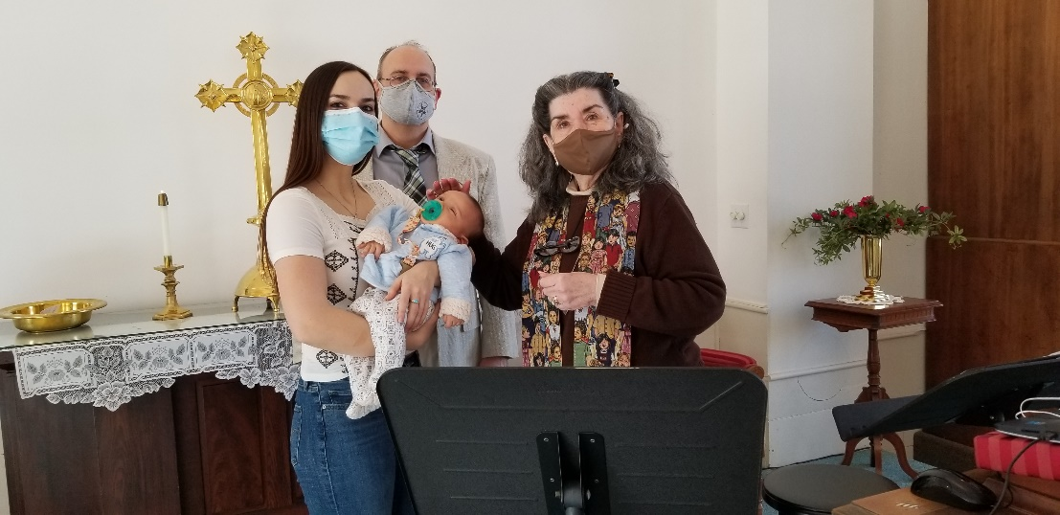
- Damon Stroms He was baptized on January 31 at Mason Church also present were his mom and his grandfather, Stefani and Marc Stroms. The baptism was performed by Reverend Veronica, witnessed by a Deacon, and the church members and friends on Zoom. You can congratulate the family at 509 Old County Rd, Mason, NH 03048

Photo is from baptism 1/31/21

- Sustainability Local News: There is a website, www.masonnhenergy.org that you can access for how to save energy in your home by tapping into Ever Source’s energy savings ideas, by find out how to solarize your house thru a “barn raising” kind of idea that will save you about 30% of the costs of adding solar. Check out the videos of Mason solar arrays. The 26% return on your investment by the Federal Government, makes your investment in the future a real savings now. The more solar arrays NH has, the more stable the energy grid! Now that’s the sustainability that God’s earth deserves.

- More local news: Mason Conservation Commission has trails for you to explore! Try the newly trimmed up Bronson Potter Trails off Greenville Rd, or the Florence Roberts Trail off Valley Road. Go to the Town website, and find more info under the Conservation Commission tab. This is a way to refresh your soul in nature, and to energize your body.
Remember our church family in your prayers, a call, or a card. Loneliness can be relieved by caring and connection, at least temporarily, and price of this “gift” is mostly free!

- Jean Randle passed away on January 5, 2021 at the age of 90. She was at home with her daughter, Ellen Randle (Judge Ellen Randle) Send hope and love cards to: 192 Millbrook Drive, East Long Meadow, MA 01028 Ellen Randle (413) 531-6864

- Harry Spears Remember Harry as it takes months to heal from the heart surgery he had in the fall. You can send cards to his home. 966 Starch Mill Rd, Mason, NH 03048. Or give him a call at 400-9209 Harry has been a friend of Mason Church for many years, and participated in worship this summer under the Maple Tree. A special time for all!

- Steve Tamulonis Steve moved up North to help out with aging family, and we will miss him A LOT. He has been the Mason Musician for over 20 years. If there was music happening somewhere, you were likely to see Steve there. He participated in our choir, our Coffee House, our Praise Band, and organized other musical events in Mason. The youth group benefitted by his leadership and support as well. And the Town of Mason has looked tidy and trimmed due to his mowing, trimming, painting, and repairs. His neighbors benefitted by his thoughtful help in dozens and dozens of ways. He will always be welcome here! His new address is: Steve and Jeanne 24 River Street, Ashland NH 03217

- Prayer Shawl Ministry We think of Susan Suokko who has been the backbone of the Prayer Shawl Ministry, we are in need of prayer shawls. We continue to have calls from friends of friends, or relatives of friends who want a special shawl. We can mail these out, but it should be done thru a request to Rev Veronica or a Deacon. We sew on a 3 inch crocheted cross, if you would like, and adapt the Prayer Shawl poem with the person’s name, and name of family members if indicated. Knitters needed! I can provide yarn and pattern for any knitters. Contact Michelle 878-1680 or miscott39@gmail.com.

- Susan and Jim Suokko have moved to Florida for now. Their Florida address is: 8814 28th Ave. Palmetto, FL 34221. They are a permanent part of our church family, and so keep in touch with them!.

- Laila Washburn has left us at the venerable age of 101 years old. She’s another beloved member of our church community. You can send love, prayers, and gratefulness for the life of Laila to: granddaughter Kristen Kivela, 25 Will Road, New Ipswich, NH 03071 and daughter Heidi Haley, 415 Old Bennington Rd, Greenfield, NH 03047
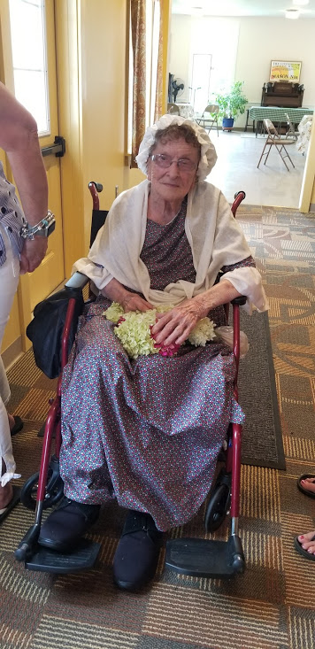
Here is Laila at Mason 250th Celebration

- Gretchen and Wally Brown Always in need of a little cheer, Gretchen needs contact with the outside world, so stop by with a wave through the window, bring a meal, or just P
to pick up syrup and say hello!
Cards to: 421 Meetinghouse Hill Rd, Mason, NH 03048 phone: 878-1481

- Remembering Jon Pearson His partner, Pat Greene, who called Jon her ‘rockstar’ is missing him profoundly. Her address is: 1275 Valley Rd, Mason, NH 03048

- Remembering Curt Dunn who died last spring, and who did get a burial service where people did gather, despite Covid.

Need a ride? Please spread the word about CVTC. It’s free to riders, and the drivers can be reimbursed for gas! A win-win all around. It’s so simple to pick up a trip, give the ride, (make a new friend or two), and the CVTC administration is efficient and kind. Really kind!
Due to Covid and the average age of the drivers, they are in need of drivers to serve the community. Drivers are vetted carefully, have excellent driving records, and are frequently reviewed by the riders.

